1.Configure Classic Load balancerObjective
Create a Classic Load Balancer to distribute incoming HTTP traffic across two Apache EC2 instances.

Prerequisites
- 2 EC2 instances running Apache
- Instances in the same VPC
- Security group allowing HTTP (80) Step 2: Create Classic Load Balancer
- Open AWS Console.
- Go to EC2 Dashboard.
- In the left menu, click Load Balancers.
- Click Create Load Balancer.
- Select Classic Load Balancer.

- Step 3: Basic Configuration
- Enter:
- Name: my-classic-lb
- Scheme: Internet-facing
- VPC: Select your VPC
- Under Listeners:
- Load Balancer Protocol | - Load Balancer Port | - Instance Protocol | - Instance Port
- HTTP | - 80 | - HTTP | - 80
- Click Next.

- Step 4: Configure Security Group
- Create or select a security group.
- Inbound Rule:
- Type | - Port | - Source
- HTTP | - 80 | - 0.0.0.0/0
- Click Next.

- Step 5: Configure Health Check
- Configure:
- Ping Protocol: HTTP
Ping Port: 80
Ping Path: /
Response Timeout: 5
Interval: 30
Unhealthy Threshold: 2
Healthy Threshold: 10
- Click Next.

- Step 6: Add EC2 Instances
- Select both Apache EC2 instances.
- Click Add to registered.
- Click Next.

- Step 7: Review and Create
- Review all settings.
- Click Create.
- Wait for the load balancer state to become Active.

- Step 8: Update EC2 Security Groups
- For both instances, add:
- Type | - Port | - Source
- HTTP | - 80 | - CLB Security Group
- or temporarily:
- Type | - Port | - Source
- HTTP | - 80 | - 0.0.0.0/0

- Step 9: Check Instance Health
- Go to EC2 → Load Balancers.
- Select my-classic-lb.
- Open Instances tab.
- Expected:
- Instance 1 - InService
Instance 2 - InService

- Step 10: Test the Load Balancer
- Select the Classic Load Balancer.
- Copy the DNS name.
- Example:
- my-classic-lb-123456789.us-east-1.elb.amazonaws.com
- Open in browser:
- http://my-classic-lb-123456789.us-east-1.elb.amazonaws.com
- Refresh multiple times.
- You should see:
- Apache Server 1
- and
- Apache Server 2
- alternately.

- Validation
- Classic Load Balancer status is Active.
- Both EC2 instances show InService.
- Health checks pass successfully.
- Accessing the CLB DNS name displays the Apache page.
- Traffic is distributed across both EC2 instances.

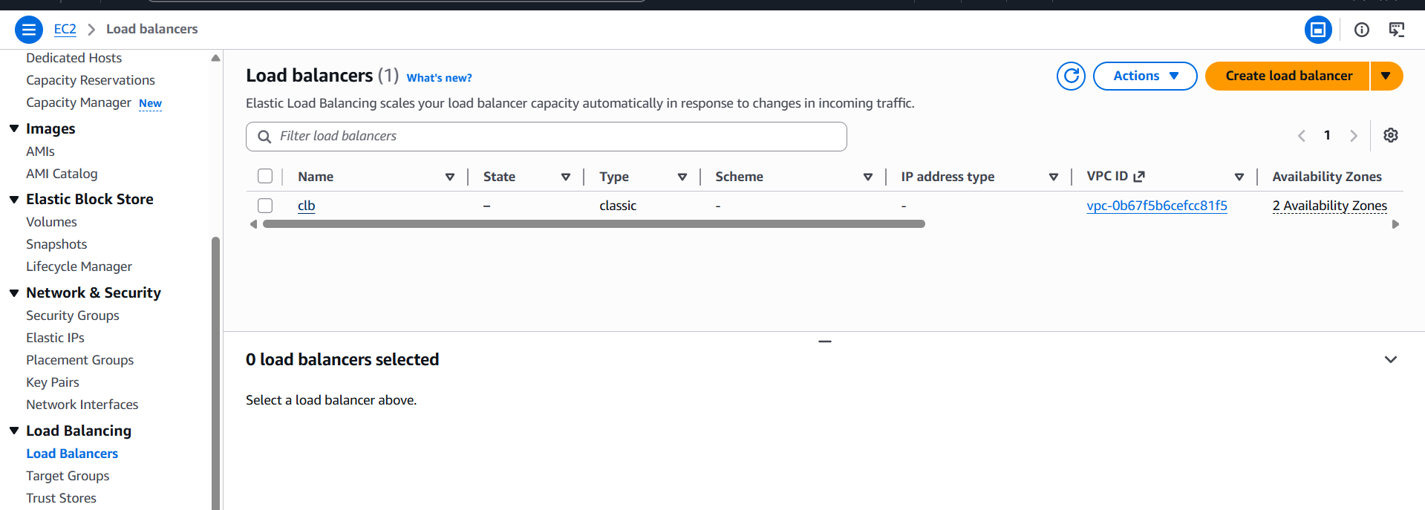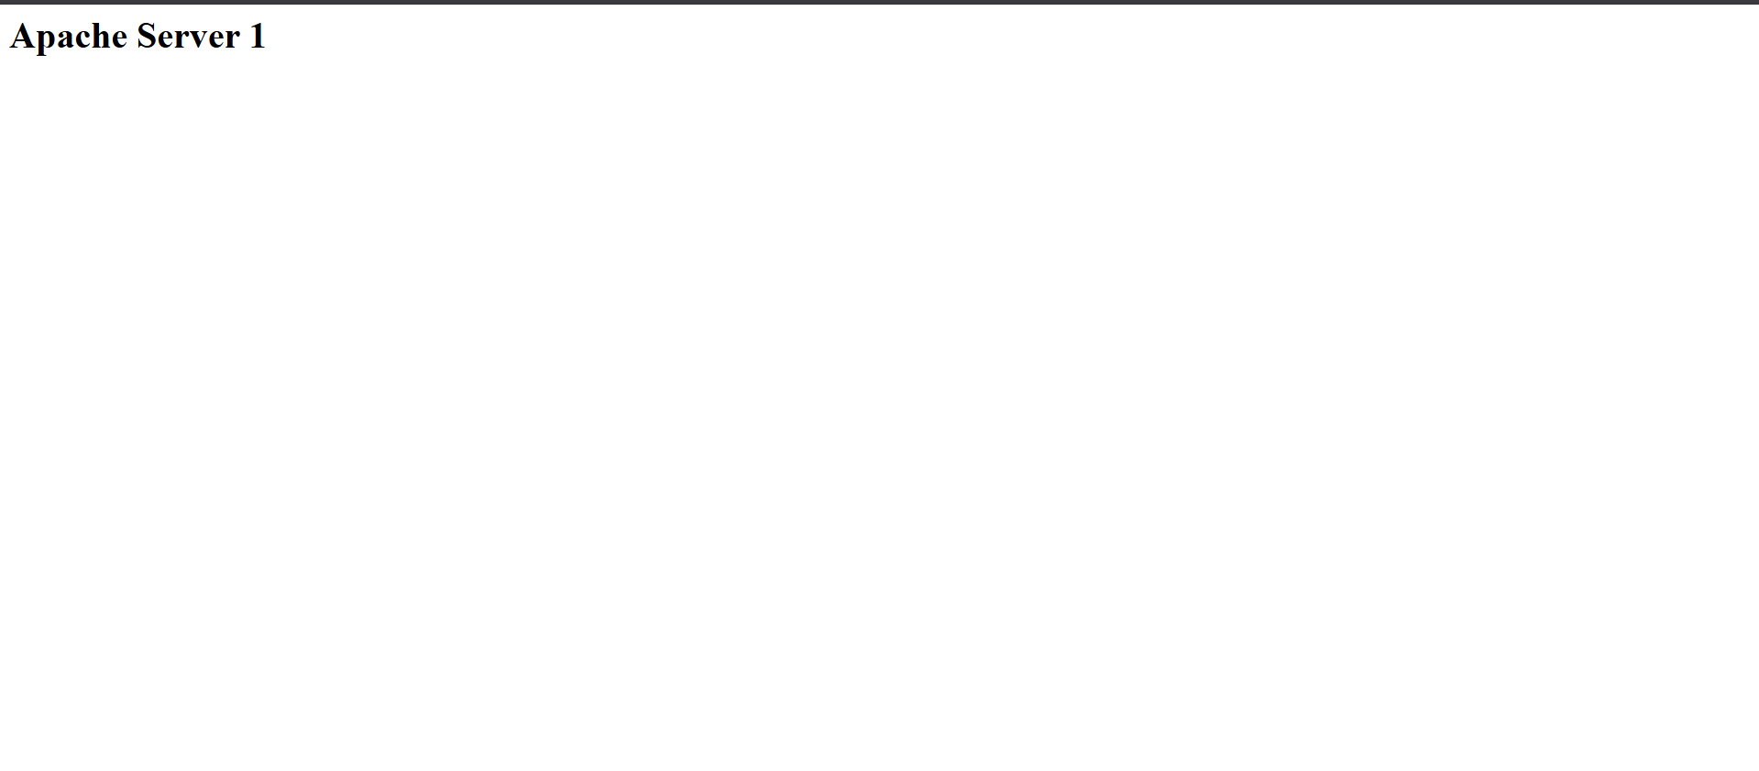

2.Configure Application Load balancerConfigure Application Load Balancer (ALB) – Step by Step
Objective
Create an Application Load Balancer (ALB) and distribute HTTP traffic across two Apache EC2 instances.

Step 1: Verify Prerequisites
Ensure you have:
- 2 EC2 instances running Apache
- Both instances in the same VPC
- At least 2 subnets in different Availability Zones
- HTTP (Port 80) enabled on the instances
Example:
Instance | Subnet | AZ
EC2-1 | 10.0.0.0/20 | us-east-1a
EC2-2 | 10.0.16.0/24 | us-east-1b

Step 2: Create Target Group
- Go to EC2 Console → Target Groups.
- Click Create target group.
- Configure:
  - Target type: Instances
  - Name: apache-tg
  - Protocol: HTTP
  - Port: 80
  - VPC: Select your VPC
- Click Next.
- Select both EC2 instances.
- Click Include as pending below.
- Click Create target group.

Step 3: Create Application Load Balancer
- Go to EC2 Console → Load Balancers.
- Click Create Load Balancer.
- Select Application Load Balancer.
- Click Create.
Basic Configuration
- Name: apache-alb
- Scheme: Internet-facing
- IP Address Type: IPv4

Step 4: Configure Network Mapping
- Select your VPC.
- Select two public subnets in different Availability Zones.
Example:
- Public Subnet 1 → 10.0.0.0/20 (us-east-1a)
- Public Subnet 2 → 10.0.16.0/24 (us-east-1b)
Click Next.

Step 5: Configure Security Group
Create or select an ALB Security Group.
Inbound Rules
Type | Protocol | Port | Source
HTTP | TCP | 80 | 0.0.0.0/0
Click Next.

Step 6: Configure Listener and Routing
Listener:
Protocol | Port
HTTP | 80
Default Action:
- Forward to Target Group: apache-tg
Click Next.

Step 7: Review and Create
- Review all settings.
- Click Create Load Balancer.
- Wait until the ALB status changes to Active.

Step 8: Update EC2 Security Group
For both EC2 instances:
- Open the instance Security Group.
- Edit Inbound Rules.
- Add:
Type | Port | Source
HTTP | 80 | ALB Security Group
Save changes.

Step 9: Verify Target Health
- Go to Target Groups.
- Select apache-tg.
- Open Targets tab.
Expected:
Instance 1 - Healthy
Instance 2 - Healthy
If status is Initial, wait 2–3 minutes.

Step 10: Test the ALB
- Go to Load Balancers.
- Select apache-alb.
- Copy the DNS Name.
Example:
apache-alb-123456789.us-east-1.elb.amazonaws.com
- Open it in a browser:
http://apache-alb-123456789.us-east-1.elb.amazonaws.com
You should see the Apache webpage.

Validation
- ALB state is Active.
- Target Group shows 2 Healthy Targets.
- Accessing the ALB DNS name displays the Apache page.
- Refreshing the page routes traffic between both EC2 instances.
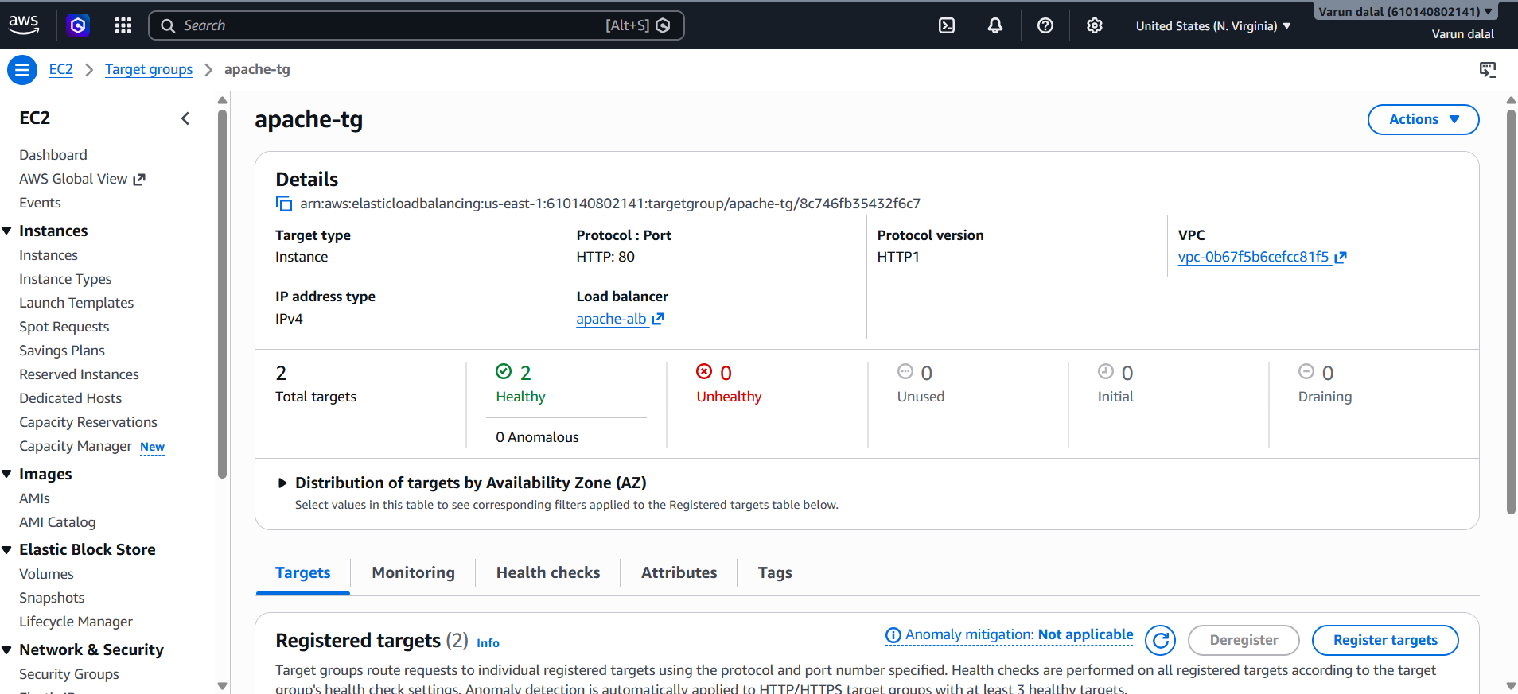



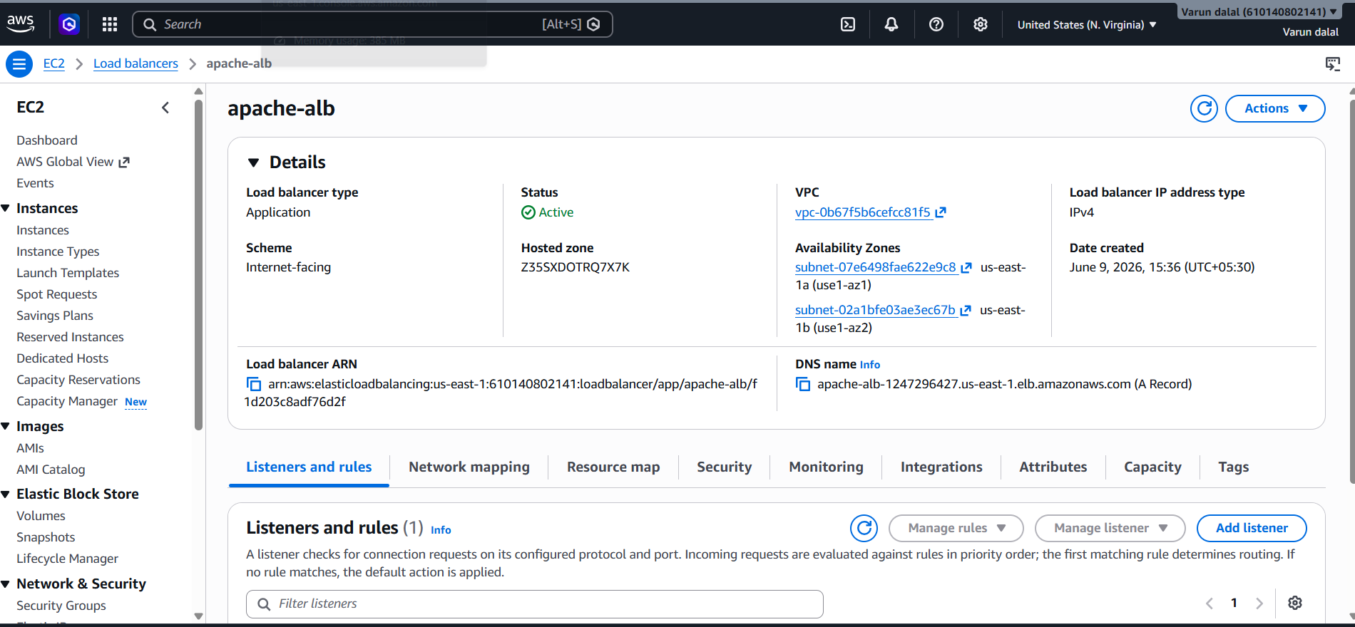

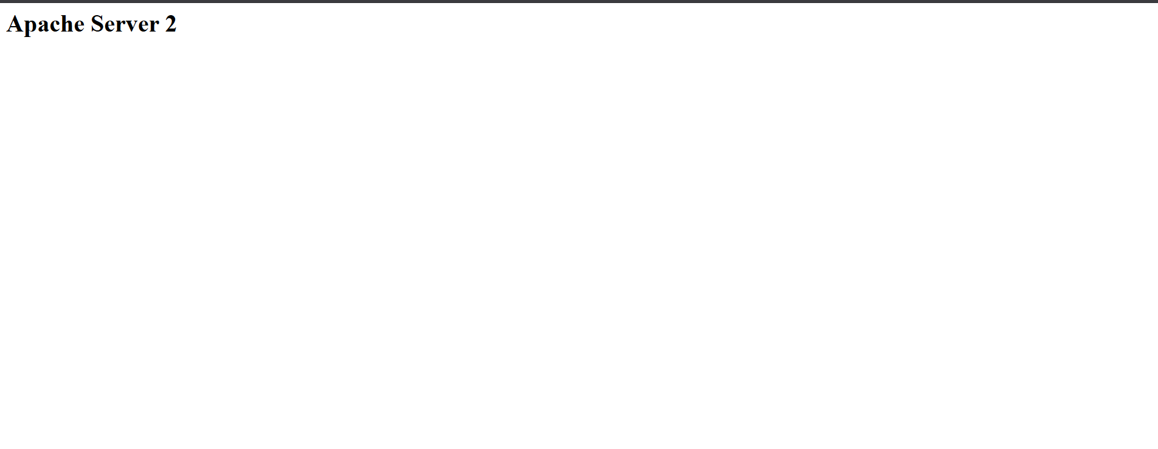

3.Configure Network Load balancerStep 2: Create a Target Group
- Open EC2 Console.
- In the left pane, click Target Groups.
- Click Create Target Group.
Configure
- Target Type: Instances
- Name: apache-nlb-tg
- Protocol: TCP
- Port: 80
- VPC: Select your VPC
Click Next.
Register Targets
- Select both EC2 instances.
- Click Include as pending below.
- Click Create Target Group.

Step 3: Create Network Load Balancer
- Go to EC2 → Load Balancers.
- Click Create Load Balancer.
- Select Network Load Balancer.
- Click Create.

Step 4: Basic Configuration
Enter:
- Name: apache-nlb
- Scheme: Internet-facing
- IP address type: IPv4

Step 5: Network Mapping
Select:
- Your VPC
- Public Subnet 1 (AZ-1)
- Public Subnet 2 (AZ-2)
Example:
Subnet | Availability Zone
10.0.0.0/20 | us-east-1a
10.0.16.0/24 | us-east-1b
Click Next.

Step 6: Configure Listener
Add Listener:
Protocol | Port
TCP | 80
Forward to:
apache-nlb-tg
Click Next.

Step 7: Review and Create
- Review all settings.
- Click Create Load Balancer.
Wait until the NLB status becomes Active.

Step 8: Configure EC2 Security Group
For both EC2 instances, ensure inbound rules allow:
Type | Protocol | Port | Source
HTTP | TCP | 80 | 0.0.0.0/0
For better security, allow traffic only from the VPC CIDR if appropriate.

Step 9: Verify Target Health
- Go to Target Groups.
- Select apache-nlb-tg.
- Open the Targets tab.
Expected:
Instance 1 - Healthy
Instance 2 - Healthy

Step 10: Test the NLB
- Go to Load Balancers.
- Select apache-nlb.
- Copy the DNS Name.
Example:
apache-nlb-123456789.us-east-1.elb.amazonaws.com
- Open in browser:
http://apache-nlb-123456789.us-east-1.elb.amazonaws.com
You should see the Apache webpage.

Validation
- NLB status is Active.
- Target Group shows both EC2 instances as Healthy.
- Accessing the NLB DNS name displays the Apache webpage.
- Traffic is distributed across the registered EC2 instances
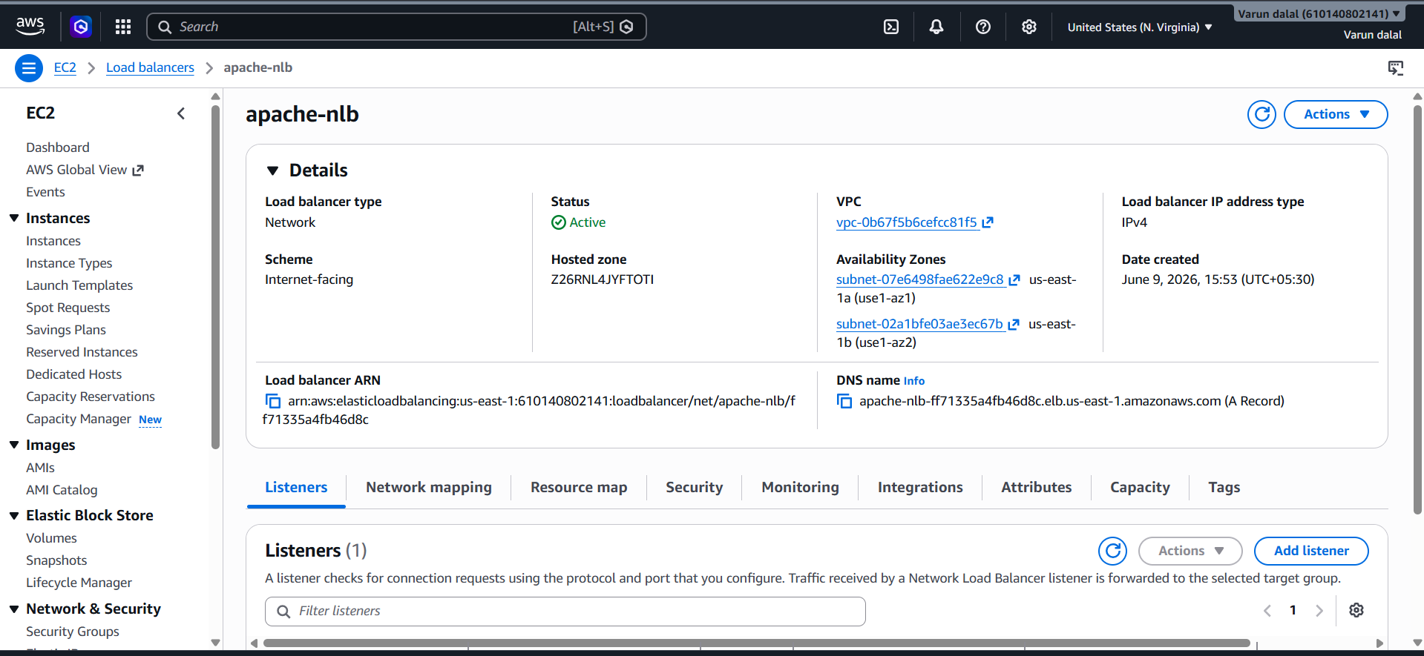

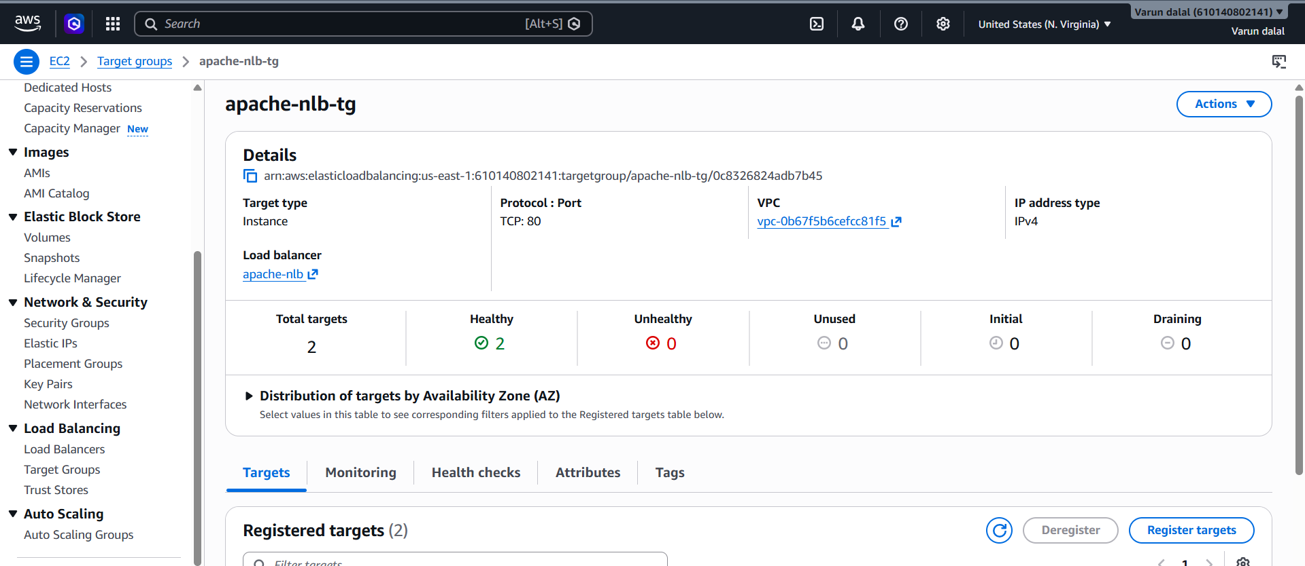

4. Attach SSL Certificate to an Application Load Balancer (ALB)
Objective
Secure your application by enabling HTTPS (Port 443) on the Application Load Balancer using an SSL/TLS certificate from AWS Certificate Manager (ACM).

Step 1: Request an SSL Certificate
- Open AWS Certificate Manager (ACM).
- Click Request Certificate.
- Select Request a public certificate.
- Click Next.
- Enter your domain name:
  - Example: example.com
  - Or *.example.com for a wildcard certificate.
- Select DNS Validation.
- Click Request.

Step 2: Validate the Certificate
- Open the certificate details.
- Click Create records in Route 53 (if your domain is in Route 53).
- Wait a few minutes.
Certificate status should change to:
Issued

Step 3: Open the Application Load Balancer
- Go to EC2 Console.
- Click Load Balancers.
- Select your Application Load Balancer.
- Open the Listeners and Rules tab.

Step 4: Add HTTPS Listener
- Click Add Listener.
- Configure:
Protocol | Port
HTTPS | 443
- Forward to your existing target group (e.g., apache-tg).

Step 5: Attach SSL Certificate
- Under Secure Listener Settings, select:
  - From ACM
- Choose the certificate you created.
- Select the default security policy.
- Click Add or Save.

Step 6: Configure HTTP to HTTPS Redirect (Optional)
- Select the existing HTTP:80 listener.
- Click Edit Listener.
- Change the default action:
Redirect to HTTPS
Settings:
Setting | Value
Protocol | HTTPS
Port | 443
Status Code | HTTP_301
Save changes.

Step 7: Verify Security Group
For the ALB Security Group, allow:
Type | Port | Source
HTTP | 80 | 0.0.0.0/0
HTTPS | 443 | 0.0.0.0/0
Save the rules.

Step 8: Test HTTPS
Copy the ALB DNS name:
https://your-alb-dns-name
Example:
https://apache-alb-123456789.us-east-1.elb.amazonaws.com
Open it in a browser.
You should see:
- A secure lock icon 🔒
- Apache webpage loading over HTTPS

Validation
- ACM certificate status is Issued.
- HTTPS listener on port 443 is configured.
- SSL certificate is attached to the ALB.
- Accessing https://<ALB-DNS> loads the website successfully.
- HTTP requests automatically redirect to HTTPS (if redirect is configured).
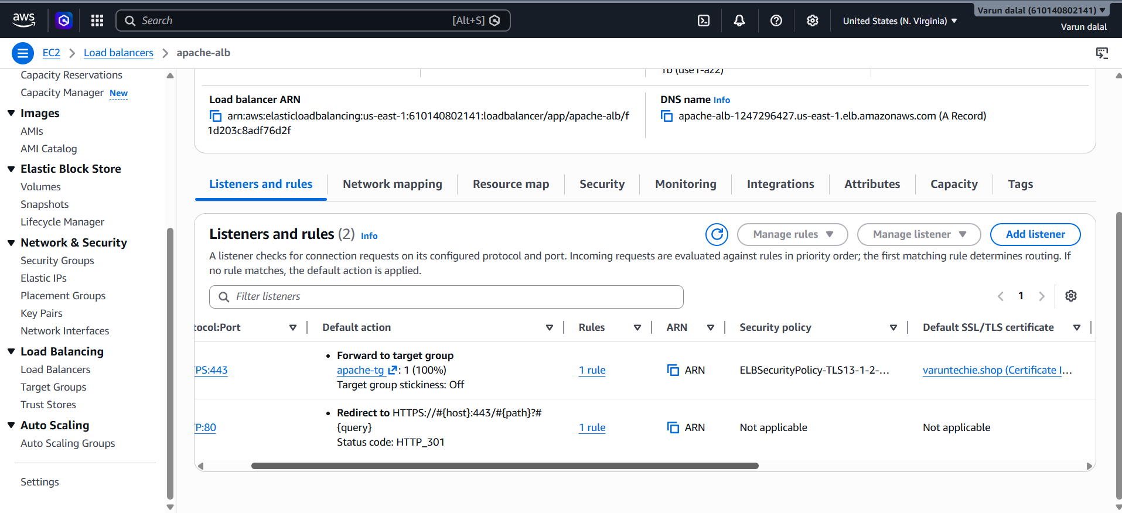

5. To map your Application Load Balancer (ALB) to the domain varuntechie.shop using Route 53, follow these steps:
Objective
Access your application using:
http://varuntechie.shop
instead of the ALB DNS name.

Step 1: Get the ALB DNS Name
- Open EC2 Console.
- Go to Load Balancers.
- Select your ALB.
- Copy the DNS name, for example:
my-alb-123456.us-east-1.elb.amazonaws.com

Step 2: Open Route 53 Hosted Zone
- Open Route 53.
- Select the hosted zone varuntechie.shop.
- Click Create Record.

Step 3: Create an Alias Record
Configure:
Setting | Value
Record Name | Leave blank
Record Type | A
Alias | ON
Route traffic to | Alias to Application and Classic Load Balancer
Region | Same region as ALB (e.g., us-east-1)
Load Balancer | Select your ALB
Routing Policy | Simple
Evaluate Target Health | Yes
Click Create Records.

Step 4: (Optional) Create WWW Record
Create another record:
Setting | Value
Record Name | www
Record Type | A
Alias | ON
Target | Same ALB

Step 5: Verify Name Servers
In your domain registrar, ensure these Route 53 name servers are configured:
ns-392.awsdns-49.com
ns-1509.awsdns-60.org
ns-1631.awsdns-11.co.uk
ns-793.awsdns-35.net
If the domain was purchased outside AWS, update the nameservers there.

Validation
Run:
nslookup varuntechie.shop
or
dig varuntechie.shop
The result should resolve to your ALB.
Then open:
http://varuntechie.shop
You should see the webpage served by the instances behind the ALB.

If the ALB still doesn't open via the domain, send:
- A screenshot of the Route 53 records.
- The ALB DNS name.
- Whether the domain was purchased in Route 53 or another registrar.
I can then identify the exact misconfiguration.
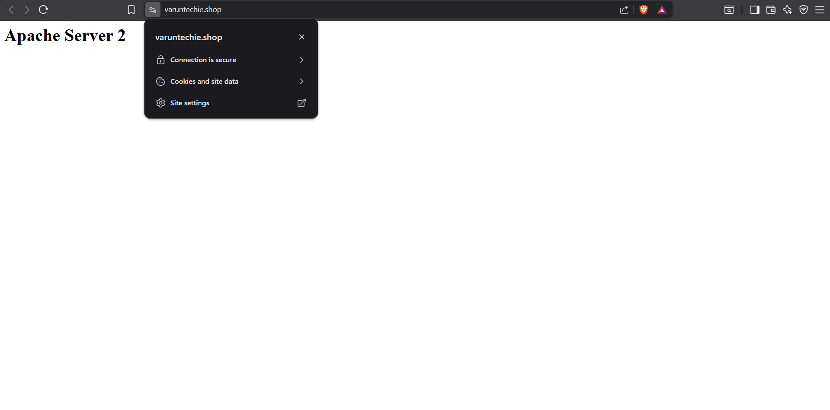

6. Push Application Load Balancer (ALB) Logs to S3
Objective
Enable Application Load Balancer access logging so that all incoming requests to the ALB are stored in an S3 bucket for monitoring, troubleshooting, and auditing.

Step 1: Create an S3 Bucket
- Open S3 Console.
- Click Create bucket.
- Enter a unique bucket name, for example:
varun-alb-logs-bucket
- Select the same AWS Region as your ALB.
- Leave default settings and create the bucket.

Step 2: Add Bucket Policy
- Open the bucket.
- Go to Permissions → Bucket Policy.
- Add a policy allowing Elastic Load Balancing to write logs.
Step 3: Enable Access Logs on the ALB
- Open EC2 Console.
- Navigate to Load Balancers.
- Select your Application Load Balancer.
- Choose the Attributes tab.
- Click Edit.
- Under Monitoring, enable Access Logs.
- Select the S3 bucket you created.
- (Optional) Enter a prefix:
alb-logs
- Save changes.

Step 4: Generate Traffic
Open the ALB DNS name or your domain multiple times:
http://your-domain-name
or
http://your-alb-dns-name
This generates requests that will appear in the access logs.

Step 5: Verify Logs in S3
After a few minutes:
- Open the S3 bucket.
- Navigate to:
AWSLogs/
ACCOUNT_ID/
elasticloadbalancing/
- You should see .log.gz files created by the ALB.

Validation
- Access logging is enabled in ALB attributes.
- Log files are automatically created in the S3 bucket.
- Opening a log file shows request details such as:
  - Client IP
  - Request URL
  - HTTP Method
  - Response Code
  - Target Instance
  - Processing Time
This confirms that ALB access logs are successfully being delivered to S3.
